Query the list of CITY names starting with vowels (i.e., a, e, i, o, or u) from **STATION**. Your result cannot contain duplicates.

**Input Format**

The **STATION** table is described as follows:

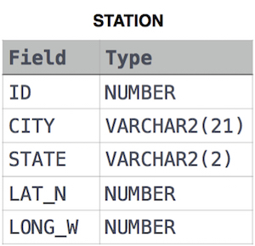

where LAT_N is the northern latitude and LONG_W is the western longitude.

Solution:

SELECT DISTINCT CITY

FROM STATION

WHERE CITY LIKE 'A%' OR CITY LIKE 'E%' OR CITY LIKE 'I%' OR CITY LIKE 'O%' OR CITY LIKE 'U%';